How to use your Raspberry Pi as a Wireless Access Point (WAP)
Start the Raspberry Pi, go to and to -> Preferences -> Raspberry Pi Configuration
Once the Raspberry Pi is on the first thing to do is to set up country, time zone, keyboard and WiFi to the appropriate location in this case United States eastern.
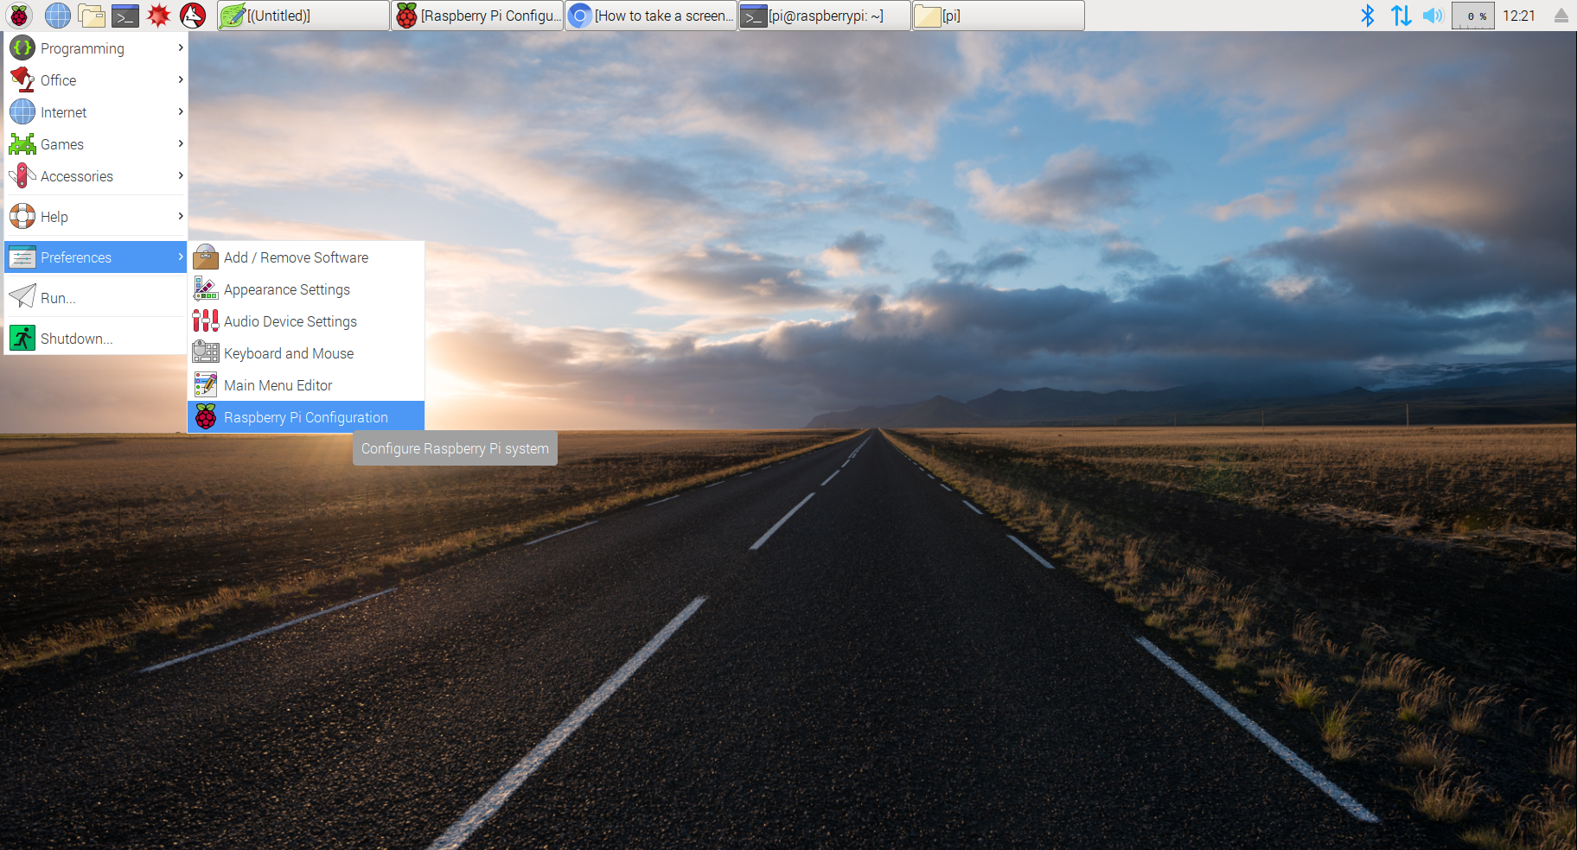
Figure 1. Starting Raspberry Pi configuration system
On the configuration windows, in Localisation:
- Set keyboard to English(US)
Set WiFi Country to US
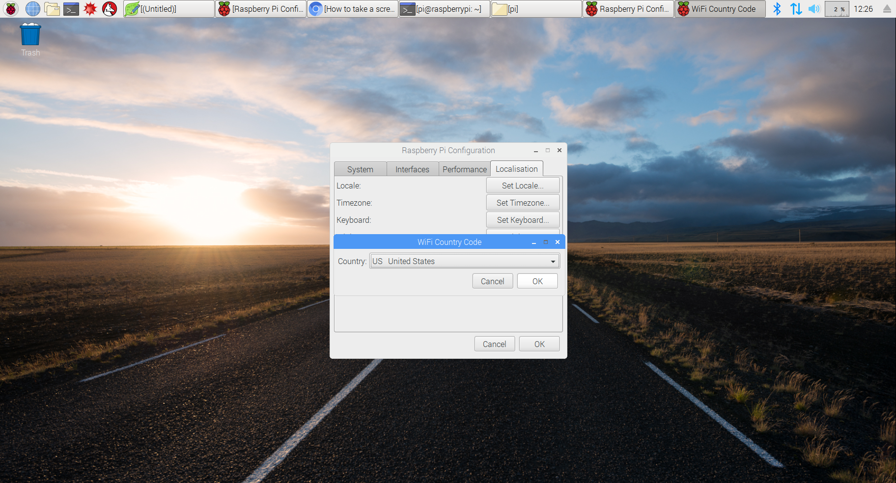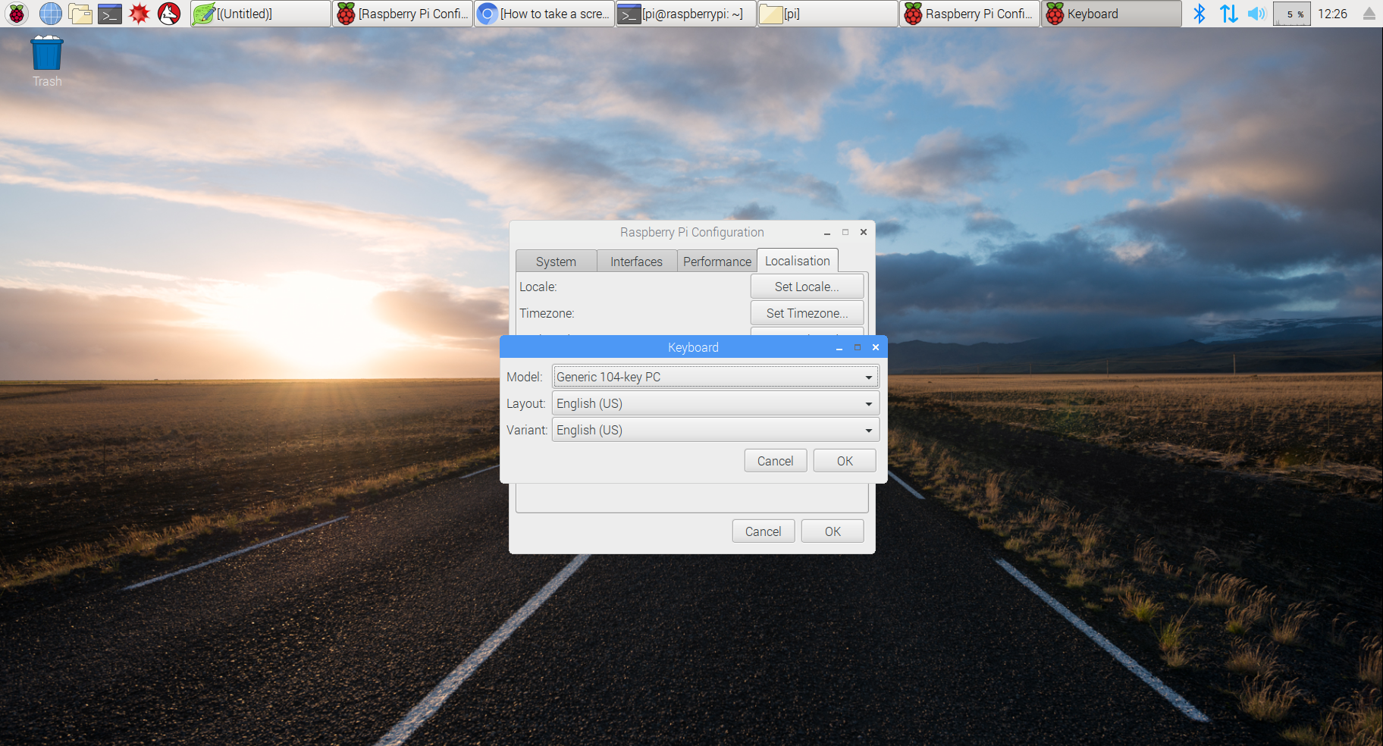
Figure 2. Set WiFi Country Code Figure 3. Set Timezone
Then follow steps 1 through 9 to configure the Raspberry Pi as WAP
Step 1: Update and Upgrade Raspbian: respectively with the following commands:
sudo apt-get update
sudo apt-get upgrade
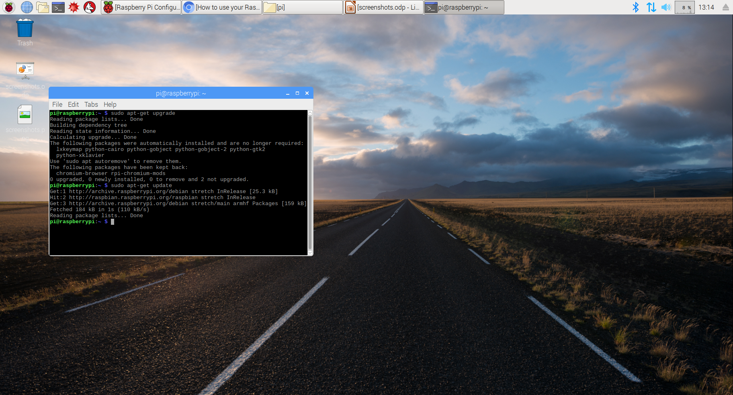
Figure 4. Updating and upgrading the System
Once the upgrade is done reboot the system with following command:
sudo reboot
Step 2: Install hostapd and dnsmasq
hostapd and dnsmasq are the two programs we are going to use to turn the Raspberry Pi into WAP. hostapd allows us to use the built in WiFi as an access point. dnsmasq serves as both Dynamic Host Configuration Protocol (DHCP) and Domain Name System (DNS) server
Note: Only type what is in red font do the same for all the steps
sudo apt-get install hostapd

sudo apt-get install dnsmasq
.
After the programs are installed turn them off before starting their configuration with the following commands:
sudo systemctl stop hostapd

sudo systemctl stop dnsmasq

Step 3: Configure a static IP for the wlan0 interface
For our purposes here, we’ll be using the standard home network IP addresses, like 192.168.###.###.
IP addresses are analogous to people’s assigned places in a room. They can be static (meaning permanent ) or dynamic (meaning temporary. every time a particular computer access the network the address can change)
So let’s assign the STATIC (permanent) IP address 192.168.0.10 to the wlan0 interface.
To do so we’ll edit ( open ) the dhcpcd configuration file with the following command.
sudo nano /etc/dhcpcd.conf
Once open, add the following lines at the end of the file:
interface wlan0
static ip_address=192.168.0.10/24
denyinterfaces eth0
denyinterfaces wlan0
Then we’ll save the file and exit the editor by pressing Ctrl+X, followed by Y and Enter key.
Step 4: Configure the DHCP server (dnsmasq)
Rename the default configuration file and write a new one:
sudo mv /etc/dnsmasq.conf /etc/dnsmasq.conf.orig

sudo nano /etc/dnsmasq.conf
And type the following 2 lines in there
interface=wlan0
dhcp-range=192.168.0.11,192.168.0.30,255.255.255.0,24h
And as always save and exit the file with Ctrl+X, followed by Y and Enter.

Step 5: Configure the access point host software (hostapd)
Open the hostapd config file with the command:
sudo nano /etc/hostapd/hostapd.conf
This should create a brand-new (empty) configuration file named “hostapd.conf ” in the “hostapd” folder in the “etc ” directory.
Then type in the following:
interface=wlan0
bridge=br0
hw_mode=g
channel=7
wmm_enabled=0
macaddr_acl=0
auth_algs=1
ignore_broadcast_ssid=0
wpa=2
wpa_key_mgmt=WPA-PSK
wpa_pairwise=TKIP
rsn_pairwise=CCMP
ssid=genNETWORK
wpa_passphrase=Stustudent
Note: where I have “genNETWORK” and “Stustudent,” each student should come up with his own names. This is how you’ll join the Pi’s network from other devices. In addition, wpa_passphrase (password) should be at least 8 characters long
Then we’ll save the file and exit the editor by pressing Ctrl+X, followed by Y and Enter key
Next we need to show the system the location of the configuration file:
enter the following command to edit hostapd
sudo nano /etc/default/hostapd
In this file, let’s track down the line that says #DAEMON_CONF=”” – delete the ” # ” and put the path to our config file in the quotes, so that the ligne looks as it shows in figure 5.
DAEMON_CONF="/etc/hostapd/hostapd.conf"
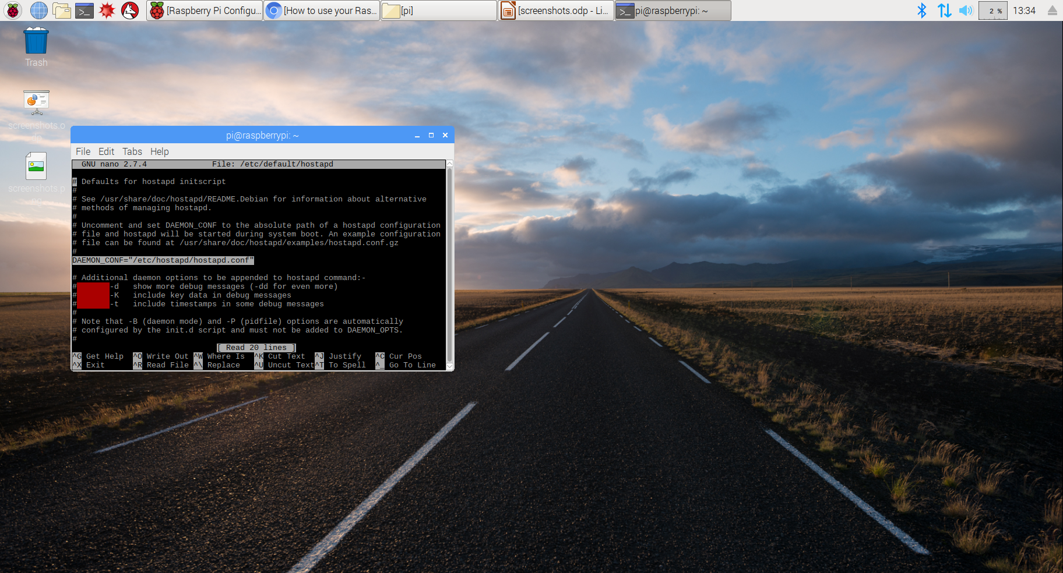
Figure 5. removing # and adding the path to hostpad.conf file
Then we’ll save the file and exit the editor by pressing Ctrl+X, followed by Y and Enter key
Step 6: Set up traffic forwarding
The idea here is that when you connect to your Pi, it will forward the traffic over your Ethernet cable. So, we’re going to have wlan0 forward via Ethernet cable to your modem. Edit the sysctl config file with the following command:
sudo nano /etc/sysctl.conf
Now find this line:
#net.ipv4.ip_forward=1
… and delete the “#” – leaving the rest, so it just reads:
net.ipv4.ip_forward=1
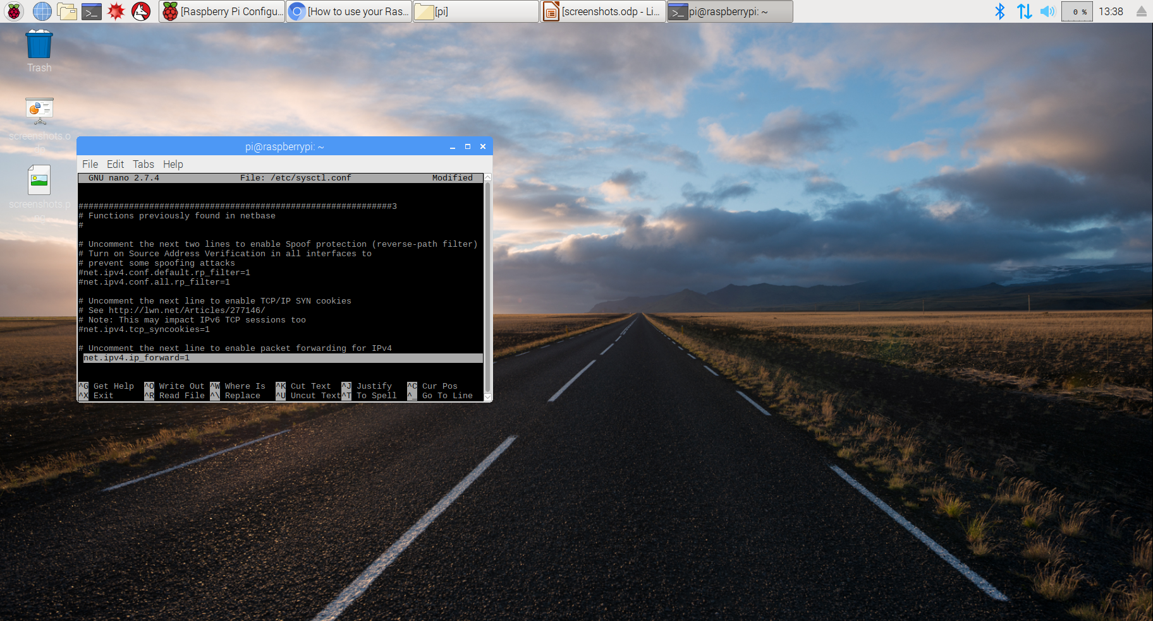
Figure 6. Deleting #. This will uncomment the line
Then we’ll save the file and exit the editor by pressing Ctrl+X, followed by Y and Enter key
Step 7: Add a new iptables rule
Next, we’re going to add IP masquerading for outbound traffic on eth0 using iptables. To do that let’s enter the following command:
sudo iptables -t nat -A POSTROUTING -o eth0 -j MASQUERADE
…and save the new iptables rule with the following command:
sudo sh -c "iptables-save > /etc/iptables.ipv4.nat"
To load the rule on boot, we need to edit the file “rc.local” located in the “etc” directory with the following command:
sudo nano /etc/rc.local
… and then add the following line just above the line exit 0:
iptables-restore < /etc/iptables.ipv4.nat
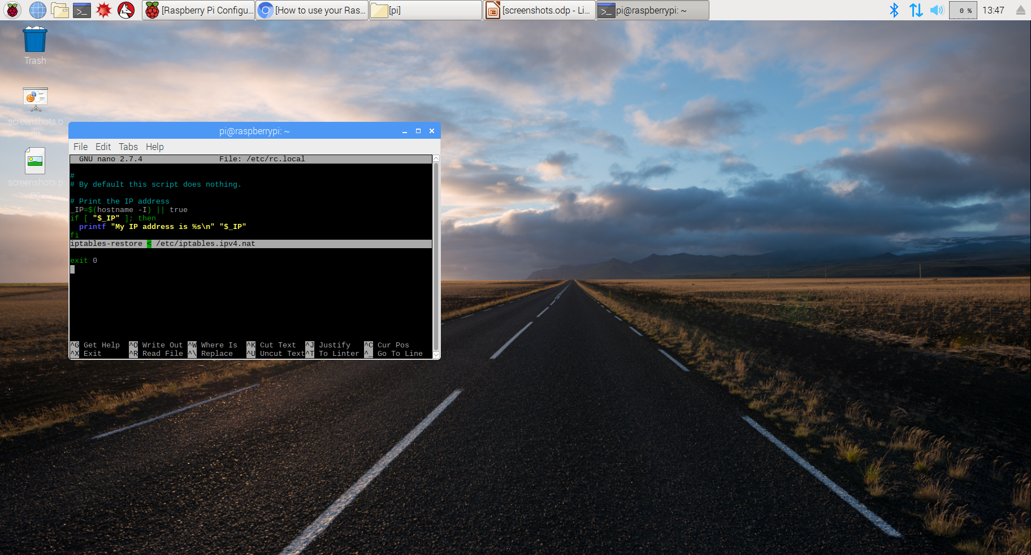
Figure 7. Adding the above line to load the rules on boot
Then we’ll save the file and exit the editor by pressing Ctrl+X, followed by Y and Enter key
Step 8: Enable internet connection
Now the Raspberry Pi should be acting as an access point to which other devices can connect. However, those devices can’t use the Pi to access the internet just yet. To make that possible, we need to build a bridge that will pass all traffic between the wlan0 and eth0 interfaces.
To build the bridge, let’s install a bridge utility with the following command:
sudo apt-get install bridge-utils
We’re ready to add a bridge (the br0 we declare in the hostapd.conf file in step 5):
sudo brctl addbr br0
Next, we’ll connect the eth0 interface to our bridge:
sudo brctl addif br0 eth0
Finally, let’s edit the interfaces file with the following command:
sudo nano /etc/network/interfaces
…and add the following lines at the end of the file:
auto br0
iface br0 inet manual
bridge_ports eth0 wlan0
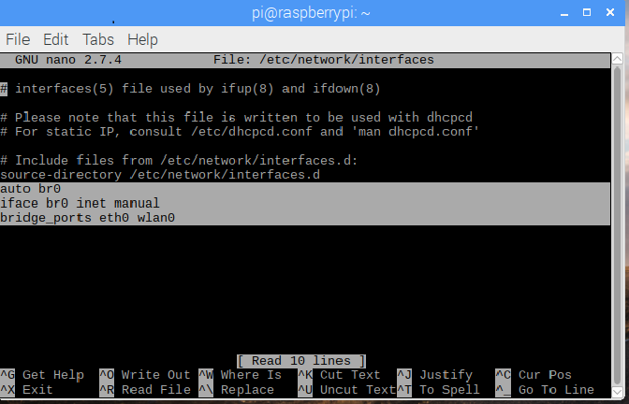
Figure 8. Adding lines to the bottom of interfaces file
Then we’ll save the file and exit the editor by pressing Ctrl+X, followed by Y and Enter key
Step 9: Reboot
Now that we’re ready, let’s reboot with sudo reboot.
Now the Pi should be working as a wireless access point. Try it out by hopping on another device and looking for the network name used back in step 5.

